35.26: From Eq. (35.14), 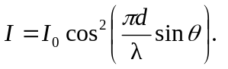So the intensity goes to zero when the cosine’s argument becomes an odd integer of 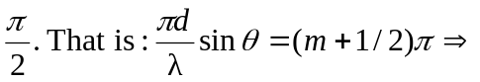 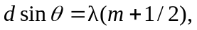 which is Eq. (35.5).

